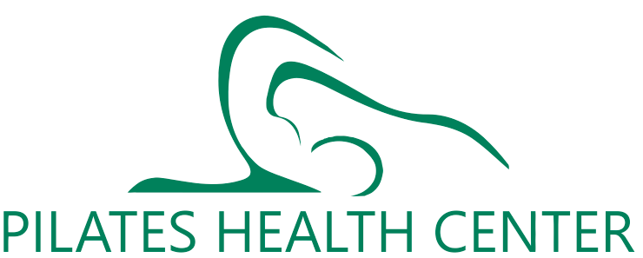
YOGA BASICS WORKSHOP
DEC. 5,12,19,26 from 12- 1 p.m.
Walking into your first YOGA class can be intimidating. It can feel like everyone is in the club except you.
* Learn about yoga basics with expert advice and help to start your practice on the right foot.
* You will be guided through the correct way of yogic breathing, proper practice of meditation and fundamental ASANAS or poses.
* You will learn the proper use of props, blocks and straps to help you achieve proper alignment.
* Yoga practice will enhance your growth, sensitivity and awareness.
* Learn the proper way of breathing, feeling and listening to your body, letting go of competition, judgment and expectations.
* This workshop is for both beginners and those returning to the practice of yoga.
* After attending you will feel confident to walk into your first beginner or all levels class.
* Small classes will ensure up close and personal instruction.
* Learn from Marina Dietrich who is a 500+ registered yoga teacher (RYT)
Sign up as soon as possible as class size is limited, All credit cards, cash and checks accepted.
Classes in private studio at bodyzone.
Marina Dietrich
Phone: 305-389-9556
Email: Marina@pilateshealthcenter.com

